Machine name: hemisphere
machine IP: 192.168.56.115

netdiscover scan
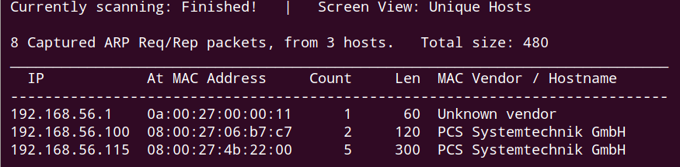

nmap scan
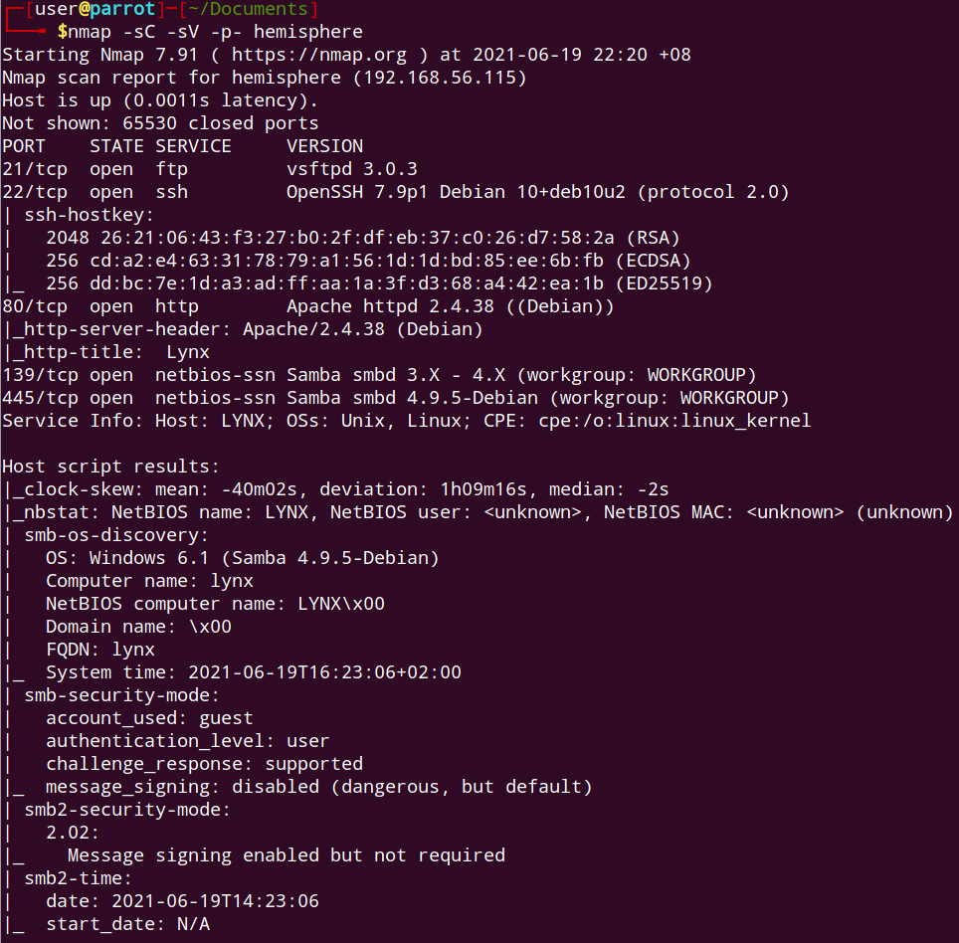

no open udp ports
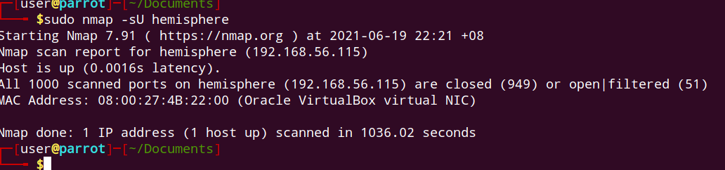

main dir larg dir scan: nothing special
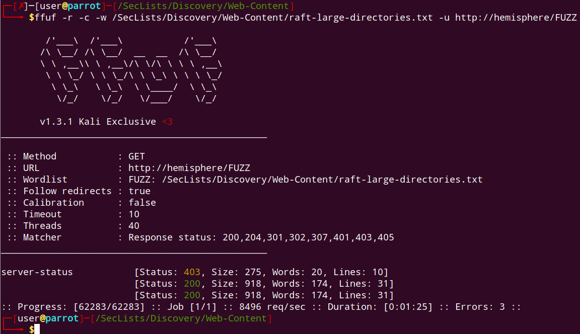

no usable shares
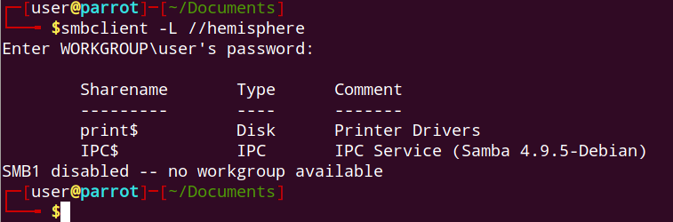

nbtstat enum: nothing special
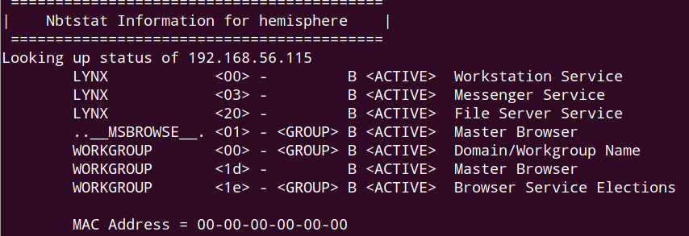

main dir: file scan, nothing special
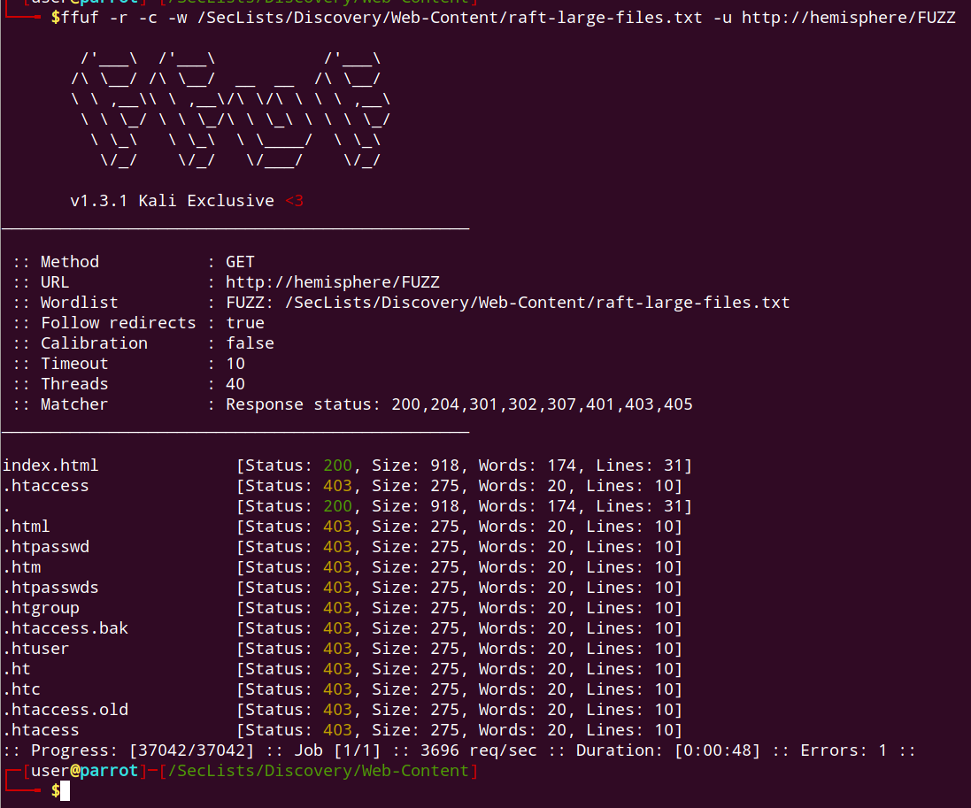

nikto scan: nothing special
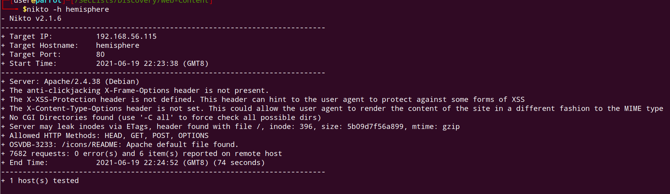

bruteforce user using enum4linux
user: johannes

Uses password based login
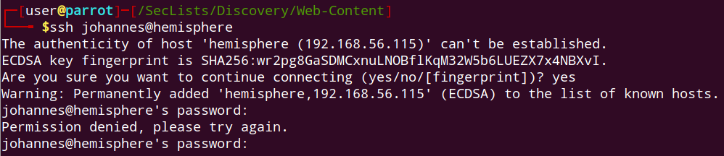

use site’s word as dictionary

brute force using msfconsole
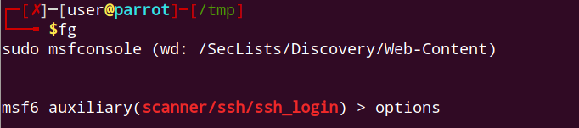

creds found
johannes:constelaciones

user flag
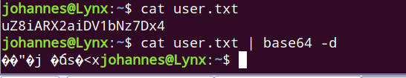

kernel is fairly recent
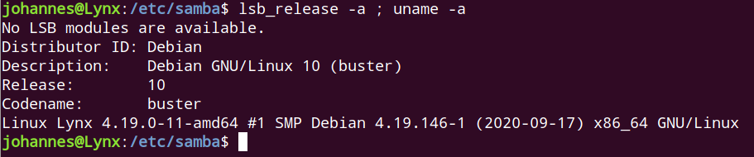

suspicious creds
20Kl7iS1KCaniO8DWMzh:toor
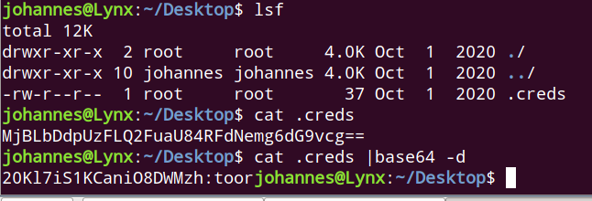

Its spelt backwards:
http://spellbackwards.com/
hzMWD8OinaCK1Si7lK02
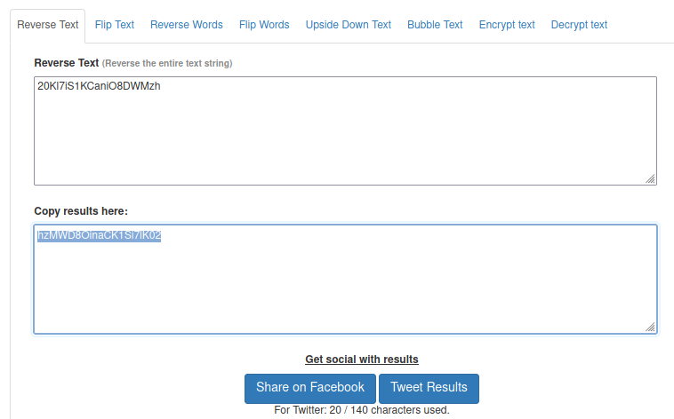

root flag
